**CAP: 457 INTRODUCTIONS TO BIG DATA - LIBORATORY**

**CONTINUOUS ASSESSMENTS (C.A)-2**

**ST_NAME : - EKHLAKH AHMAD**

**REG NO. : - 12209166**

**ROLL NO. : - RD2215B50**

**SECTION : - D2215**

**GROUP : - 2**

**DATE : - 09/03/2023**

**Q.1.**

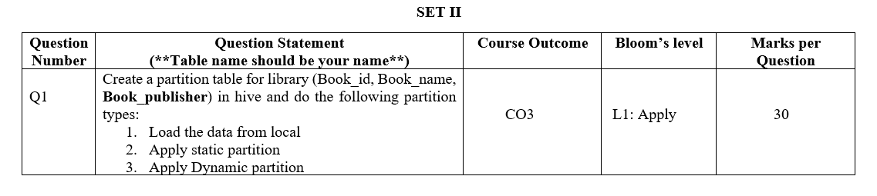

Ans: - **CREATE DATABASE WITH MY NAME EKHLAKH**

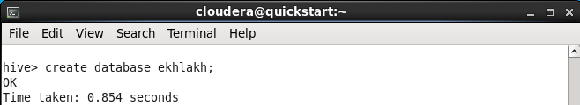

**USE THIS DATABASE FOR CREATION TABLE.**



**CREATE TABLE WITH NAME LIBRARY AND INSERT SOME DETAILS.**

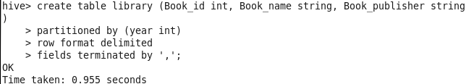

**SHOW TABLE DETAILS.**

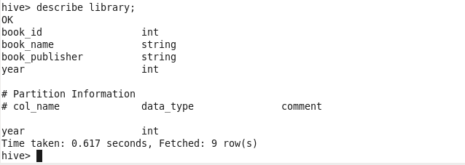

**INSERT DATA TO TABLE.**

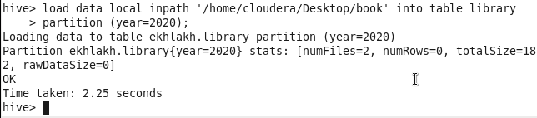

**STATIC PARTITION 2022.**

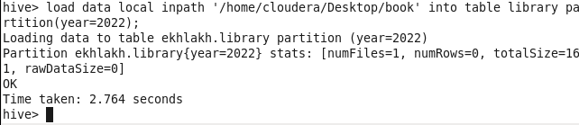

**SHOW TABLE.**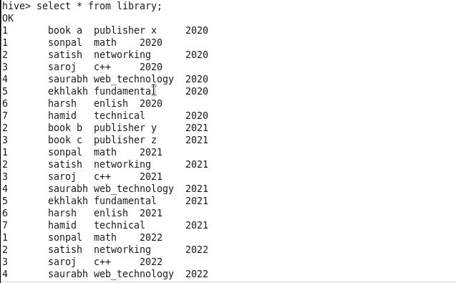

**SHOW DATA FROM PARTITION 2022.**

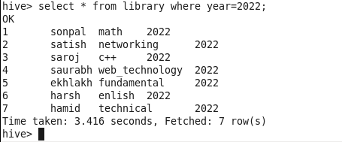

**FOR DYNAMIC PARTITION.**



**CREATE DYNAMIC TABLE.**

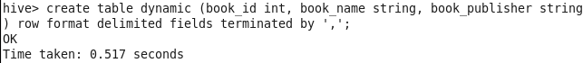

**LOAD DATA INTO TABLE.**

